**How to draw rounded corner rectangle on PDF document in ASP.NET Core application**

​The Syncfusion Essential® PDF is a feature-rich and high performance [.NET Core PDF library](https://www.syncfusion.com/pdf-framework/net-core/pdf-library) used to create, read, and edit PDF documents programmatically without Adobe dependencies. This library also offers functionality to merge, split, stamp, forms, compress, and secure PDF files.

Using this library, you can draw different shapes like line, curve, rectangle and more on PDF documents in C# and VB.NET. This sample explains how to draw a round corner rectangle on PDF document in ASP.NET Core application.

Steps to draw a round corner rectangle on PDF document in ASP.NET Core application:

1. Create a new ASP.NET Core Web application project. 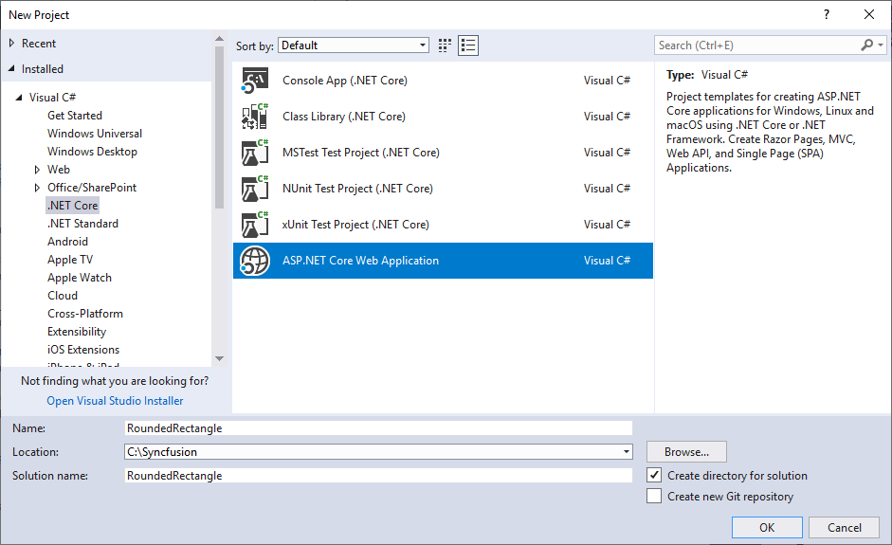
2. Select Web Application (Model-View-Controller) pattern for the project. 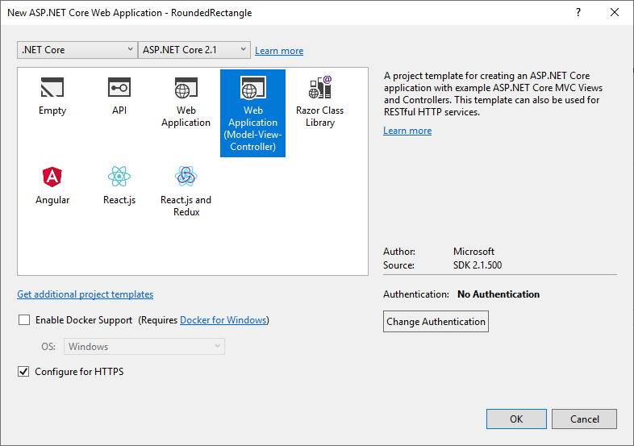
3. Install the [Syncfusion.Pdf.Net.Core](https://www.nuget.org/packages/Syncfusion.Pdf.Net.Core/) NuGet package as a reference to your .NET standard applications from the [NuGet.org](https://www.nuget.org/). 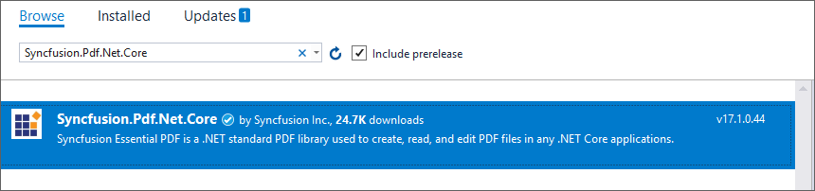
4. A default controller named *HomeController.cs* gets added on creation of the project.
5. A default action method named Index will be present in HomeController.cs. Right-click on the Index method and select Go to View where you will be directed to its view page *Index.cshtml*.
6. Add a new button in Index.cshtml as shown below.

**CSHTML**

@{**Html**.**BeginForm**("CreatePDF", "Home", **FormMethod**.Get);

    {

        <**div**>

            <**input** type="submit" value="Create PDF" style="width:150px;height:27px" />

        </**div**>

    }

**Html**.**EndForm**();

}

1. Include the following namespaces in HomeController.cs file.

**C#**

**using** Syncfusion.Drawing;

**using** Syncfusion.Pdf;

**using** Syncfusion.Pdf.Graphics;

**using** System.IO;

**VB.NET**

**Imports** System.Drawing

**Imports** Syncfusion.Pdf

**Imports** Syncfusion.Pdf.Graphics

**Imports** System.IO

1. You can draw a round corner rectangle on PDF document in .NET Standard application by using the [PdfPath](https://help.syncfusion.com/cr/file-formats/Syncfusion.Pdf.Base~Syncfusion.Pdf.Graphics.PdfPath.html) class.
2. Add a new IActionResult with name as CreatePDF and include the following code snippet to draw a round corner rectangle on PDF document.

**C#**

//Create a new PDF document

PdfDocument document = **new** PdfDocument();

//Add a new page to the document

PdfPage page = document.Pages.Add();

//Initialize graphics for the page

PdfGraphics graphics = page.Graphics;

//Represent the shape

graphics.DrawString("Rounded Rectangle", new PdfStandardFont(PdfFontFamily.Helvetica, 16), PdfBrushes.DarkBlue, **new** PointF(190,30));

//Create the rectangle

RectangleF rect = **new** RectangleF(160, 70, 200, 100);

int dimension = 30;

//Create the PdfPath

PdfPath pdfPath = **new** PdfPath();

//Draw the rounded rectangle as separate 4 arcs with same dimensions of width and height

pdfPath.AddArc(rect.X, rect.Y, dimension, dimension, 180, 90);

pdfPath.AddArc(rect.X + rect.Width - dimension, rect.Y, dimension, dimension, 270, 90);

pdfPath.AddArc(rect.X + rect.Width - dimension, rect.Y + rect.Height - dimension, dimension, dimension, 0, 90);

pdfPath.AddArc(rect.X, rect.Y + rect.Height - dimension, dimension, dimension, 90, 90);

//Close the path

pdfPath.CloseFigure();

//Draw the PDF path

graphics.DrawPath(PdfPens.Black, pdfPath);

//Saving the PDF to the MemoryStream

MemoryStream stream = **new** MemoryStream();

document.Save(stream);

//Set the position as '0'

stream.Position = 0;

//Download the PDF document in the browser

FileStreamResult fileStreamResult = **new** FileStreamResult(stream, "application/pdf");

fileStreamResult.FileDownloadName = "RoundRectangle.pdf";

return fileStreamResult;

**VB.NET**

'Create a new PDF document

**Dim** document **As** PdfDocument = New PdfDocument

'Add a new page to the document

**Dim** page **As** PdfPage = document.Pages.Add

'Initialize graphics for the page

**Dim** graphics **As** PdfGraphics = page.Graphics

'Represent the shape

graphics.DrawString("Rounded Rectangle", New PdfStandardFont(PdfFontFamily.Helvetica, 16), PdfBrushes.DarkBlue, New PointF(190, 30))

'Create the rectangle

**Dim** rect **As** RectangleF = New RectangleF(160, 70, 200, 100)

**Dim** dimension **As** Integer = 30

'Create the PdfPath

**Dim** pdfPath **As** PdfPath = New PdfPath

'Draw the rounded rectangle as separate 4 arcs with same dimensions of width and height

pdfPath.AddArc(rect.X, rect.Y, dimension, dimension, 180, 90)

pdfPath.AddArc(rect.X + rect.Width - dimension, rect.Y, dimension, dimension, 270, 90)

pdfPath.AddArc(rect.X + rect.Width - dimension, rect.Y + rect.Height - dimension, dimension, dimension, 0, 90)

pdfPath.AddArc(rect.X, rect.Y + rect.Height - dimension, dimension, dimension, 90, 90)

'Close the path

pdfPath.CloseFigure()

'Draw the PDF path

graphics.DrawPath(PdfPens.Black, pdfPath)

'Saving the PDF to the MemoryStream

**Dim** stream **As** MemoryStream = New MemoryStream

document.Save(stream)

'Set the position as '0'

stream.Position = 0

'Download the PDF document in the browser

**Dim** fileStreamResult **As** FileStreamResult = New FileStreamResult(stream, "application/pdf")

fileStreamResult.FileDownloadName = "RoundRectangle.pdf"

**Return** fileStreamResult

A complete work sample can be downloaded from [RoundedRectangle.zip](https://www.syncfusion.com/downloads/support/directtrac/general/ze/RoundedRectangle-17221342.zip).

By executing the program, you will get the PDF document as follows.

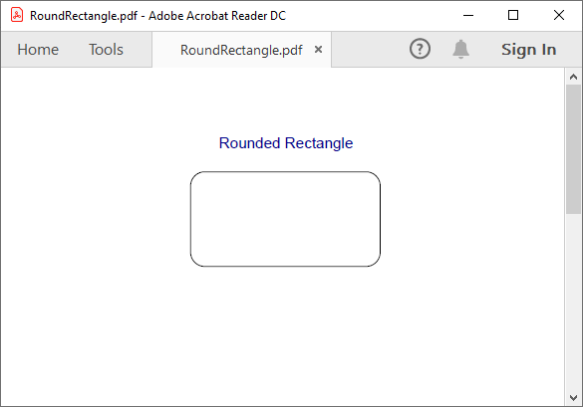

​

**Conclusion**

I hope you enjoyed learning about how to to draw rounded corner rectangle on PDF document in ASP.NET Core.

You can refer to our [**ASP.NET Core PDF feature tour**](https://www.syncfusion.com/document-processing/pdf-framework/net-core) page to know about its other groundbreaking feature representations. You can also explore our [**ASP.NET Core PDF documentation**](https://ej2.syncfusion.com/aspnetcore/PDF/Default#/bootstrap5) to understand how to present and manipulate data.

For current customers, you can check out our WinForms components from the [**License and Downloads**](https://www.syncfusion.com/account/downloads) page. If you are new to Syncfusion®, you can try our 30-day [**free trial**](https://www.syncfusion.com/downloads/aspnetcore-js2) to check out our ASP.NET Core PDF and other ASP.NET Core components.

If you have any queries or require clarifications, please let us know in comments below. You can also contact us through our [**support forums**](https://www.syncfusion.com/forums), [**Direct-Trac**](https://www.syncfusion.com/support/directtrac/incidents/), or [**feedback portal**](https://www.syncfusion.com/feedback/aspnet-core?control=pdf). We are always happy to assist you!